**Autumn Term 2 - Year 5** <http://year5meadowside.edublogs.org/>

**P.E.** this half-term we will be focusing on TAG RUGBY. Lessons will take place each **MONDAY & FRIDAY**. Blue / Black shorts or dark coloured leggings / tracksuit bottoms, a white t-shirt and warm dark coloured jumper / hoodie will be needed with suitable footwear for outdoors.  **HOMEWORK –** Handed in each **THURSDAY** and then re-set each **FRIDAY.** Each week reading (including x3 Reading Plus on-line activities), spellings and a multiplication / division grid will be set. All Homework Diaries and Reading Records should be signed by an adult at home each week. <https://student.readingplus.com/seereader/api/sec/login>

*Please ensure all items of uniform are* ***named*** *(including P.E. kits) and named water bottles and healthy snacks are brought to school EVERY DAY.*

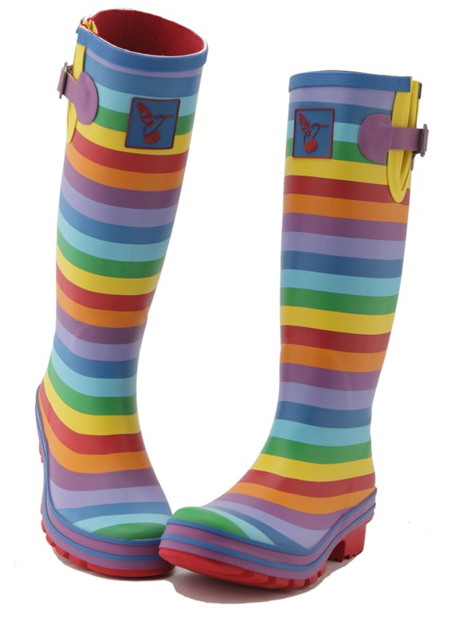



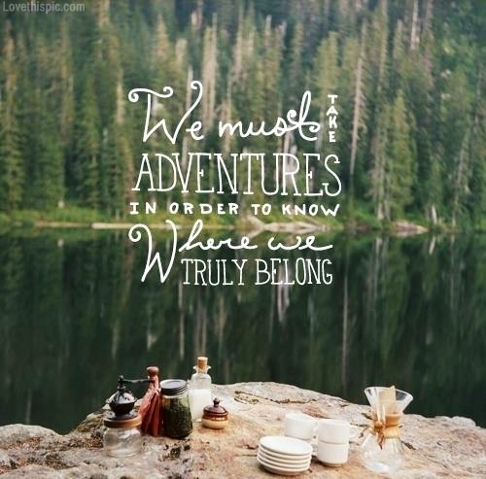

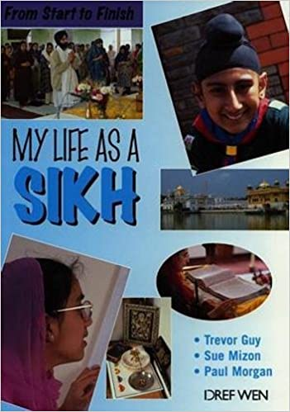 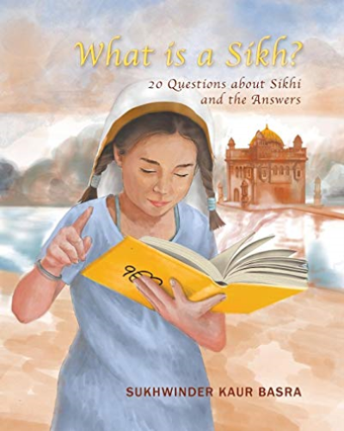

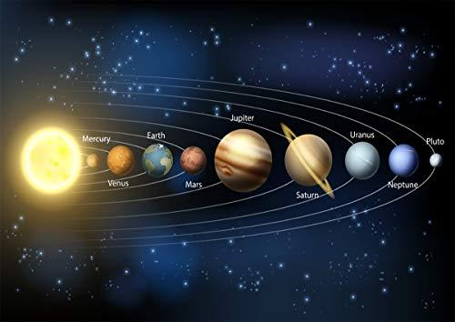

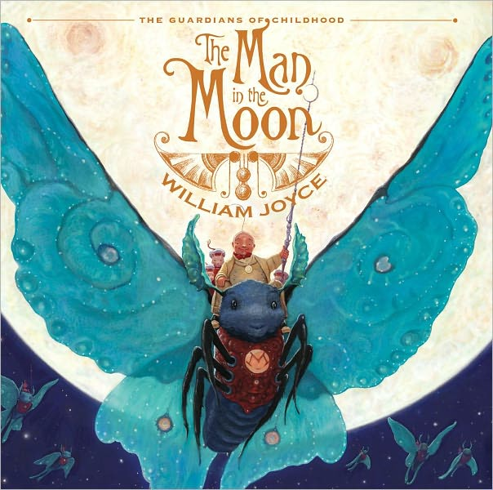



**Our Big Idea this half term:**

**I AM AN EXPLORER**

In **English**, we will begin by exploring **‘What does it mean to be a Sikh in Britain today?’** Our texts will be **‘What is a Sikh?’** and **‘My Life as a Sikh’** where we will aim to answer this question. Following on from this, we will explore **‘The Man in the Moon’** by William Joyce.

In **Maths**, we will **interpret** **negative numbers in context**. Following from this we will further develop **efficient written calculation methods** for **addition and subtraction** (see below) and **complete, read and interpret statistics represented in different forms**.

In **Science**, we will explore **‘Earth and Space’**, describing the **movement of the Earth and other planets in our Solar System**. We will learn about how **day, night** and **seasons** come to be in relation to this. We will also explore **Global Warming** – **what** this is and what the **impact** of Global warming is on **living things**.

In **Geography**, we will develop our **Locational knowledge** and **skills** as we learn about the features of **North America**. We will then also **compare and contrast Silicon Valley** to **London**.

In **MfL (Modern Foreign Languages)** we will focus on **‘On fait la fête’.** We will **celebrate** in being able to **present information** about **ourselves**.

In **Music**, we will learn to **play** the **Glockenspiel** and be able to **read** **musical** **notation**.

In **Computing**, we will use **‘Purple Mash’** to develop our skills in **Coding**. We will begin to **simplify code** and understand **functions** within it. We will also understand what **simulations** are and why these are created and used.

In **D.T. (Design and Technology)**, we will **investigate** and **analyse** different types of **fastening** before **designing**, **creating and evaluating** our own.

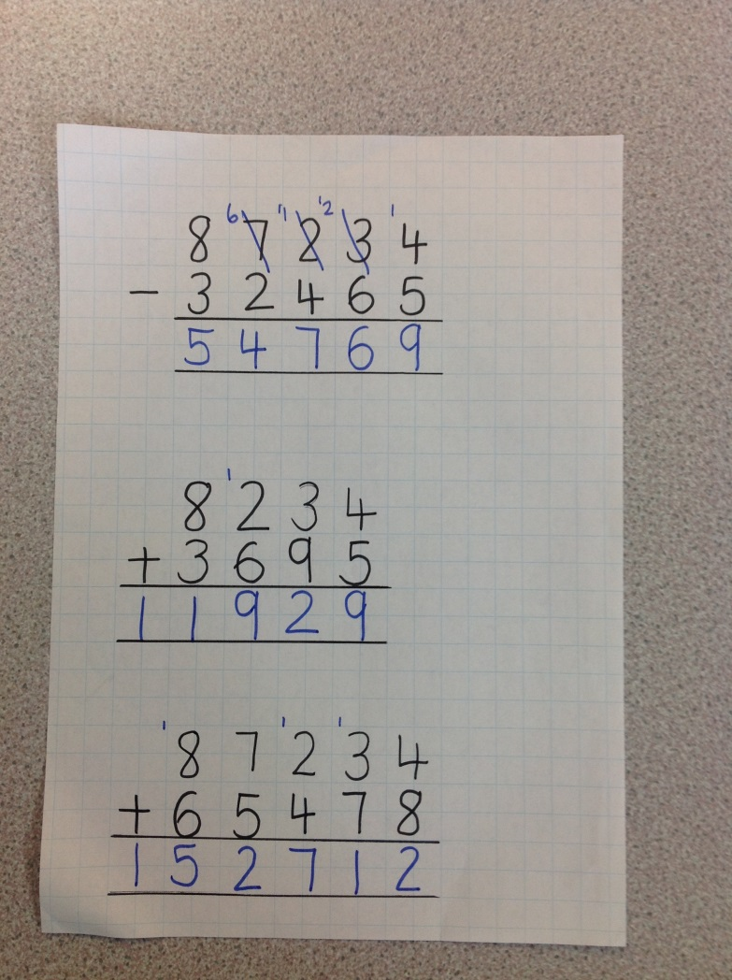

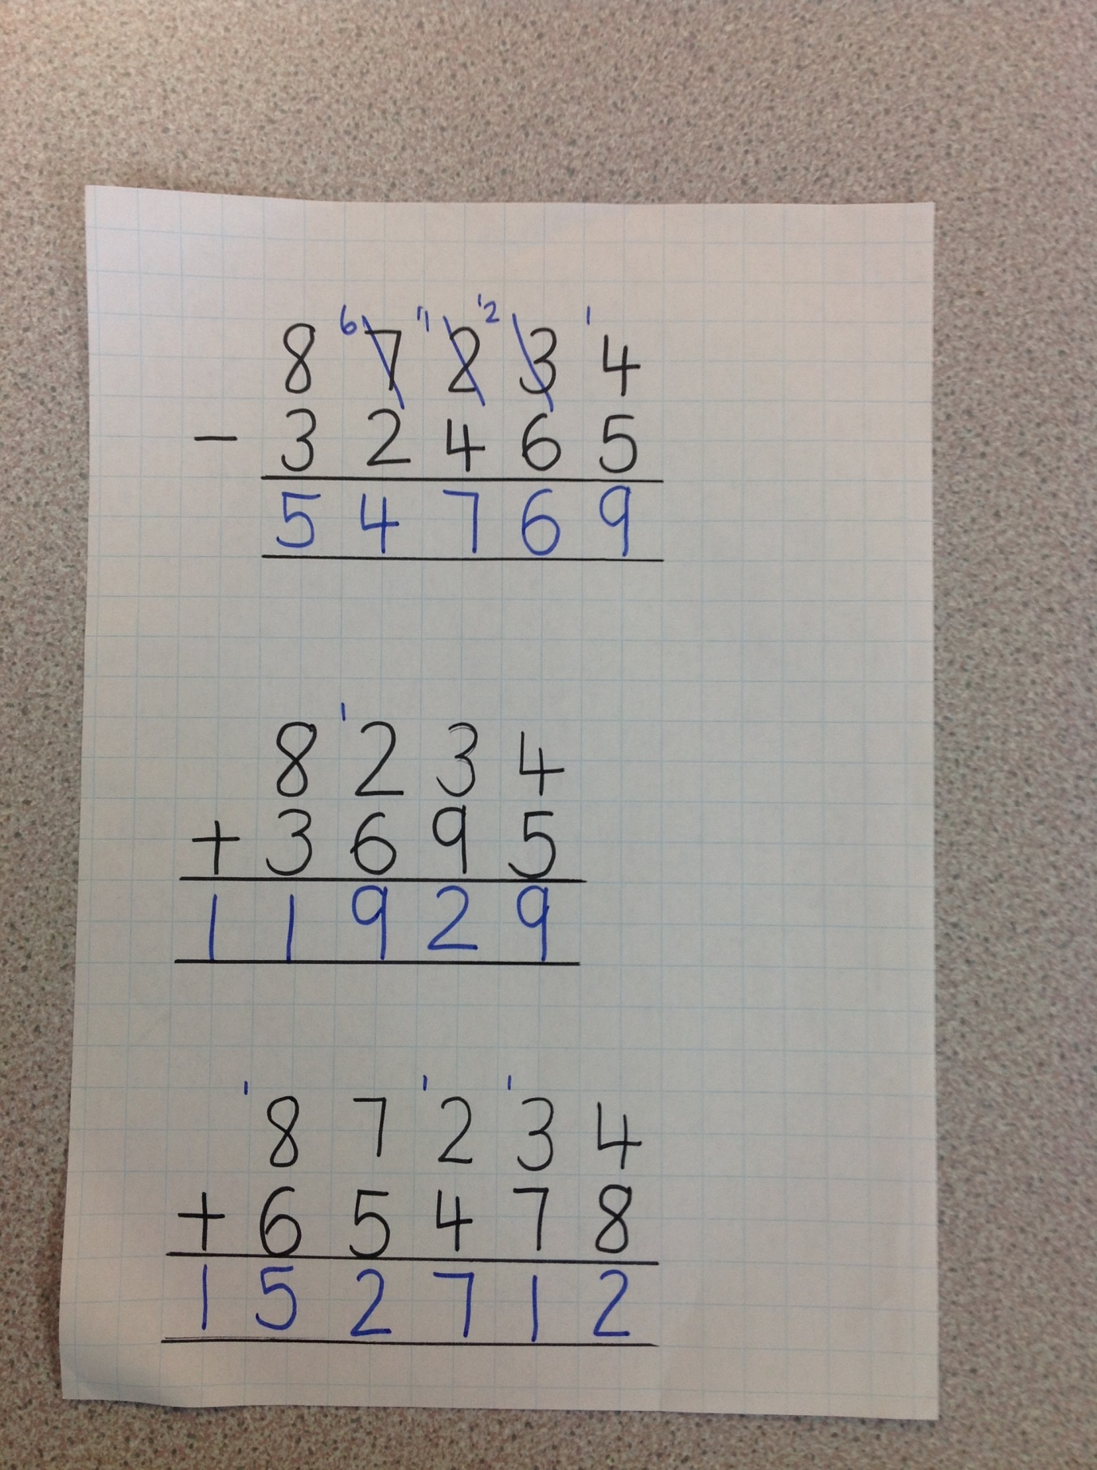

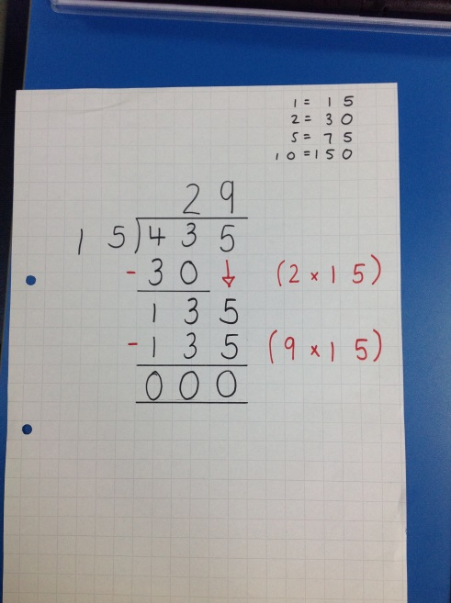

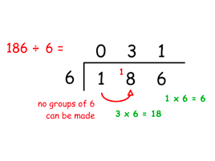

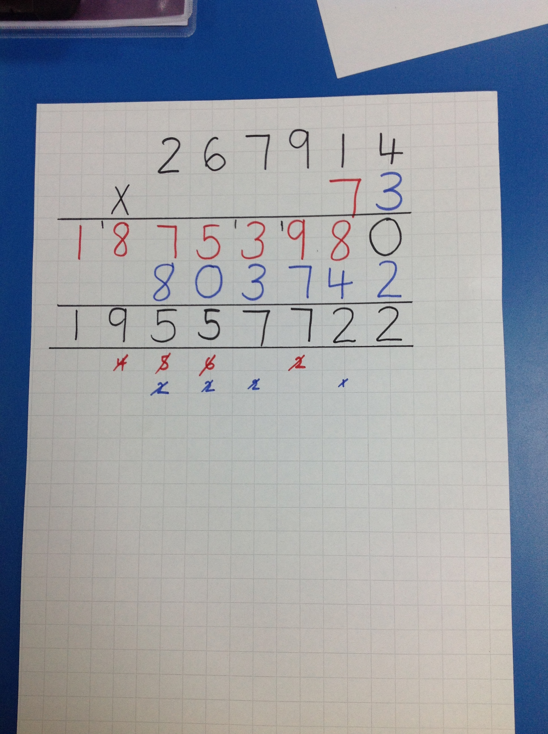

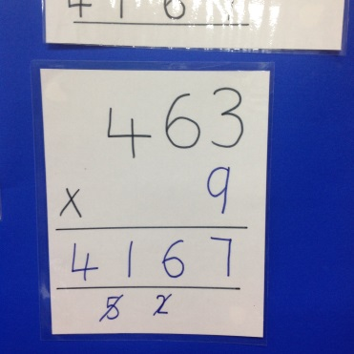

**Year 5**

